Nada Shabout

1468 words

**Huroufiyah**

The perception of the Arabic letter in art has gone through many changes from the Islamic civilization to the modern age. Following the political and socio-cultural changes of the nineteenth and twentieth century, the Arabic script lost its sacredness. After decades of limited existence in traditional craft, the Arabic letter reappeared in modern Arab art around the middle of the twentieth century on nationalistic bases. The Arabic language had acquired a high value during the age of colonialism as a symbol of national identity, a unifier; this value only grew stronger with time. The letter was also a signifier that aided twentieth century Arab artists in their artistic identity crisis. A number of art groups – such as the Baghdad Group of Modern Art, formed in 1951 – were established with their focus on a search for a local or national art styles through ‘istilham al-turath,’ seeking inspiration from tradition. The Arabic letter became the means for connecting artists’ present with their past and allowing for the invention of tradition. Huroufiyah (Arabic for Letterism), a highly contested term initiated by a newspaper journalist, became a term popularly used to signify all experiments with the Arabic letter in modern Arab art. Nevertheless, the term is surrounded by controversy in the contemporary Arab world and rejected by a number of scholars and artists. The term al-Madrassa al-Khattiya Fil-Fann (Calligraphic School of Art), has been alternatively proposed, expressing specifically a perceived continuation with Islamic calligraphy.

Despite epistemological disagreement, all agree that the use of the Arabic letter has projected a specific purpose and meaning seemingly centered on issues of identity. To this end, Huroufiyah specifically signifies a national Arab art product, or a national Arab art phenomenon that is *not* a continuation of calligraphy. It expresses a new secular consciousness and a way of re-evaluating the relationship between self and other. The term embodies several discourses that have been in the core of the formation of modern Arab art and its critique: issues of the identity of Arab art and of its locality and universality.

In general Huroufiyah is based on two principles: first, negotiating the Arabic letter as a plastic element, and second, constructing a modern work of art capable of expressing a cultural particularity. In its modern use in art, the Arabic letter has been liberated from its role in the written script, despite arguments doubting such a notion and insisting that Arabic speakers will always attempt to read the composition when confronted by letters in the work. More importantly, it challenged the letter’s sacred status as it was perceived through Islamic calligraphy. Despite calligraphy’s concreteness as a living style, its role in beautifying and glorifying the words of God in the Quran made it highly stylized and beyond reach. Its aesthetic creation was divorced from daily life in comparison to the modern use of the Arabic letter.

The beginnings of the modern use of the Arabic letter in art are found in a few individual isolated efforts. Important precedents are seen in the work of the two Iraqi artists, Madiha Umar (1908-2005) and Jamil Hammoudi (1924-2003). Both artists developed their interest in the Arabic letter while studying in Western cities.

While in the United States, Umar discovered, through books on Islamic calligraphy, the graphic possibilities of the Arabic letter and its abstractness as a form. In 1949, she exhibited twenty-two painting at the Georgetown Public Library in Washington, DC, and published a written declaration entitled ‘Arabic Calligraphy: An Element of Inspiration in Abstract Art’ that articulated her perception of its evolution through the ages into its present form, and its symbolic qualities as abstract images. Hammoudi, initially a Surrealist artis, turned to the Arabic letter for self-preservation while in Paris in 1947. His surrealism transformed into Cubist formulations of the Arabic letters that dominated his paintings.

During the 1950s, other artists experimented with the Arabic letter. Examples include the work of the Lebanese artist Wajih Nahle (b. 1932), which exhibited the influence of classical calligraphy; the work of the Lebanese Said A’kl (b. 1926); and the Sudanese artists of the Old Khartoum School with their traditional approach to calligraphy, such as Osman Waqiallah's and Ahmad Mohammed Shibrain's work.

During the 1960s, the Arabic letter attracted an increasing number of Arab artists from around the region. The artists of this second group also generally discovered or developed interest in the letter during their studies in Europe, where the Arabic word served as their constant connection to their cultures. Moreover, negotiations between text and image were not foreign to modern art. Klee, Kandinsky, and various Cubist and Surrealist artists experimented with letters and type in their work. Thus, Arab artists’ work with the Arabic letter was firmly grounded in modern art. As a trend, it gained momentum during the 1970s and 1980s, and turned into a phenomenon in which almost every Arab artist experimented at one time or another with the letter, including important experiments by Syrian artist Mahmoud Hammad; Iraqi artists Shakir Hassan Al Said, Dia Azzawi and Rafa al-Nasiri; Palestinian artist Kamal Boullata; and Algerian artist Rachid Koraichi.

Nevertheless, the practise never became a unified movement or school of style, despite several efforts. In 1971, the Iraqi artist Shakir Hassan Al Said formed the One Dimension group, consisting of a number of accomplished artists whose work centered on the use of the letter, including Umar and Hamoudi. The group was short-lived and did not constitute a coherent school of art.

It is in many ways unfair to group the different experiments with the Arabic letter in art under one label given the variety, richness and seriousness of certain experiments as oppose to the repetitiveness, decorativeness and simplicity of others. Broadly, there seem to be two separate branches within the sum of works articulating the Arabic letter. In the first the letter is but an entrance to the work, which then deals with a different creative practise and other issues, and should be evaluated accordingly. Artists working within this line of thought also viewed experiments with the Arabic letter as a necessary but transitional methodology, and many eventually abandoned it and moved beyond the period’s obsession.

In the second, the letter constitutes the work. It is within this line of thought that the popular trends of commercial Huroufiyah belong. These works are for the large part conditioned by the market, but equally provide a very affordable and safe product for the region. This specific formulation of Huroufiyah has been widely accepted, and celebrated at times, by Arab societies and officials alike. Western critics have also welcomed it from its beginnings. One of its main attractions is in facilitating a closer relationship with the traditional religious text, now presented as a sign from the mundane. Moreover, the practise further perpetuates the dominant stereotype and neo-orientalist trope in which the letter appears as the expected and familiar sign of Islamic cultures. Because of its appeal to Arabs' religious sensitivity, however, the practice has resulted in mass production of commercial Huroufiyah. These popular commercial works, which are primarily decorative and ornamental, were classified by newspaper critics as Huroufiyah, which in turn created a feeling of resentment among many established Huroufiyah artists, who subsequently opted to abandon the use of the letter in their work altogether.

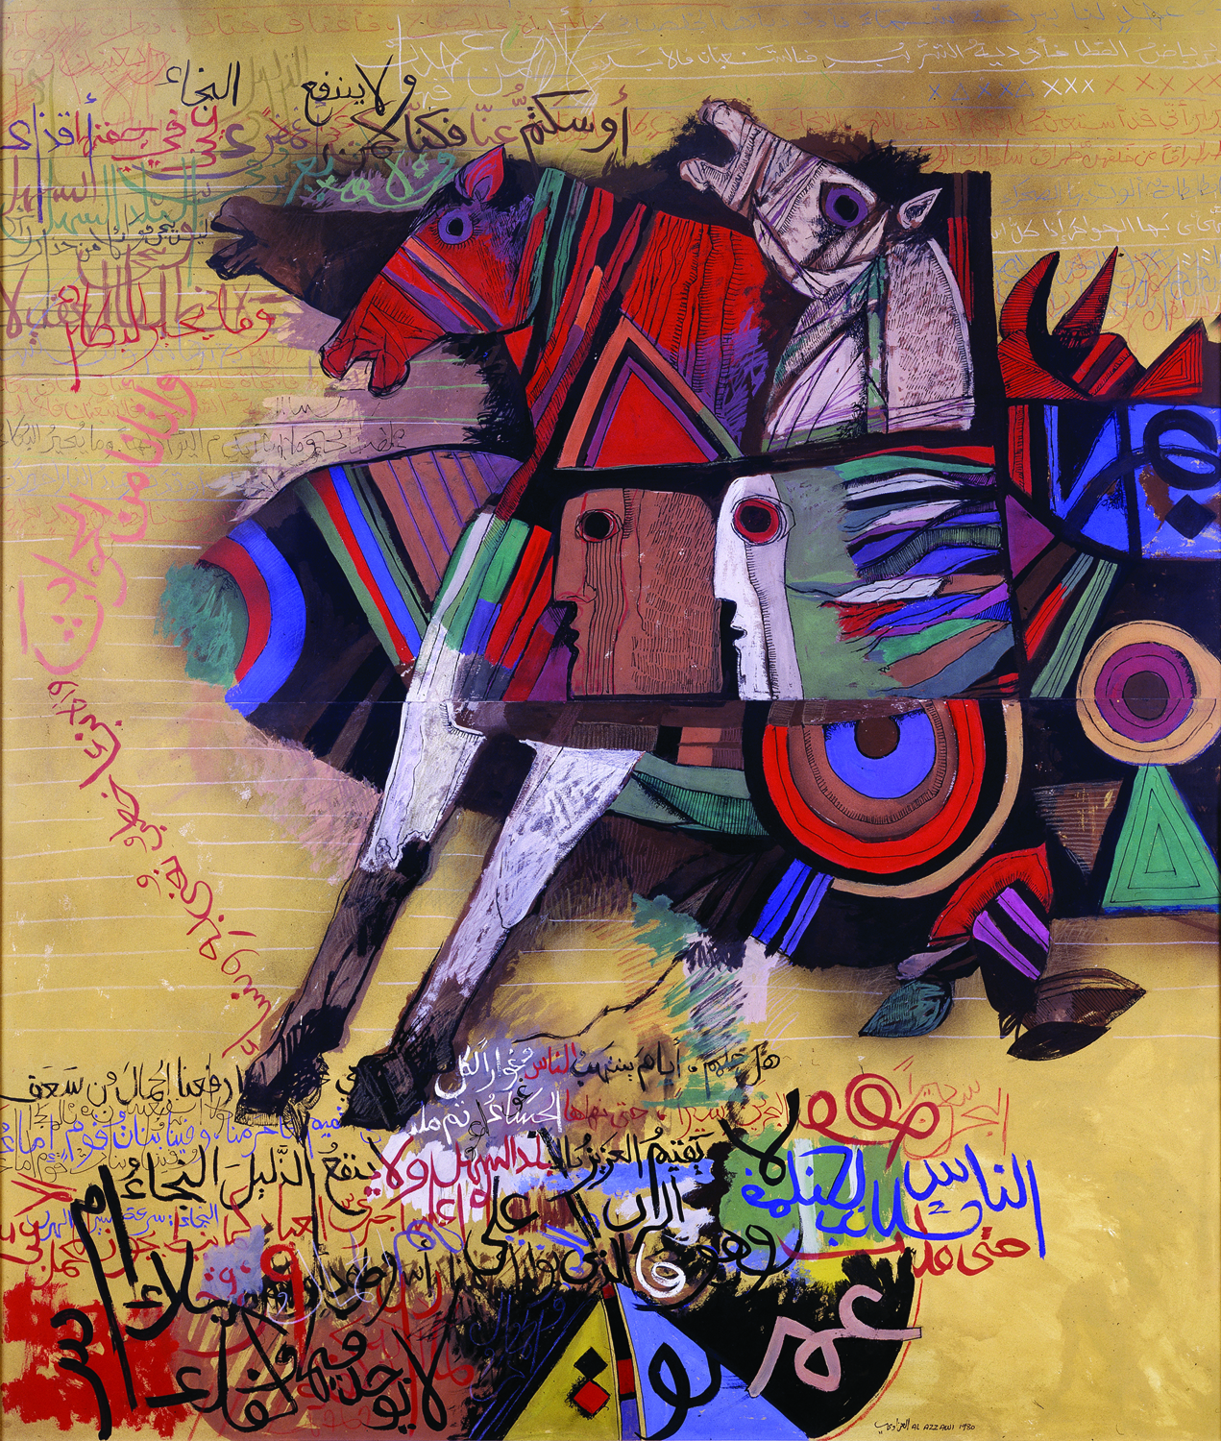

Dia Azzawi, MULAQAT AL-HARTH BIN HELIZAH, 1980. Gouache on Paper, 180 x 120 cm, Kinda Foundation, Contemporary Arab Art Collection, Riyadh.

N.B. The author has permission for the image

**References and further reading**

Al Said, Shakir Hassan (1982) "The Basic Element in my Artistic Vision," Funun Arabiyah (Arab Arts) (London), no. 7: 80–81.

Ali, Wijdan (1997) *Modern Islamic Art: Development and Continuity*, Florida: University Press of Florida.

------, ed.(1996) *The Right to Write: Calligraphic Works from the Collection of the Jordan National Gallery of Fine Arts*. Exhibition Catalogue, the Dalton Gallery, Agnes scott College, July 15–October 16, 1996. Atlanta: Caroline Joe and Mimi Pfeil.

Daghir, Shirbil (1990) Al-Hurufiyah al-Arabiyah: Fann wa Hawiyah (Arab Letterism: Art and Identity). Beirut: Sharikat al-Matbua’t Lil Tawzi’ wa al-Nashir.

________. “Dia al-Azzawi: Art Does Not Correspond to Official Statements.” Kul al-Arab (Paris), no. 4 (April 1994): 50–3.

Dallul, Ziyyad. “Hurufun ‘ala Alwan (Letter on Color).” Mawakif (London), no. 67 (Spring 1992): 151–53.

Khatibi, Abdelkebir & Mohammed Sijelmassi (1995) *The Splendour of Islamic Calligraphy*. London: Thames And Hudson.

al-Matalisi, Mohammed (1989) ed. *Croisement De Signes*. Paris: Institut du Monde Arabe.

Mikdadi-Nashashibi, Salwa, ed. (1997) Rhythm and Form: Visual Reflections on Arabic Poetry. California: International Council for Women in the Arts.

Porter, Venetia (2006, 2008) *Word into Art: Artists of the Modern Middle East,* London: The British Museum; Dubai.

Shabout, Nada (2010) *Sajjil: A Century of Modern Art. Exhibition Catalogue,*co-editor and author, Mathaf: Arab Museum of Modern Art, Doha, Qatar, Milan: Skira Publisher.

_______ (2010) “The Arabic Connection in Articulating North African Modernity in Art,”in a special issue of *South Atlantic Quarterly* 109:3, Summer: 329-343 on "African Modernism," edited by Professor Salah Hassan.

_______ )2009) “Iraqi Art: Dafatir” in *The State of the Arts in the Middle East,* by the Middle East Institute (MEI) Project, special edition of *Viewpoints.*

_______ (2007) *Modern Arab Art: Formation of Arab Aesthetics*, University of Florida Press.